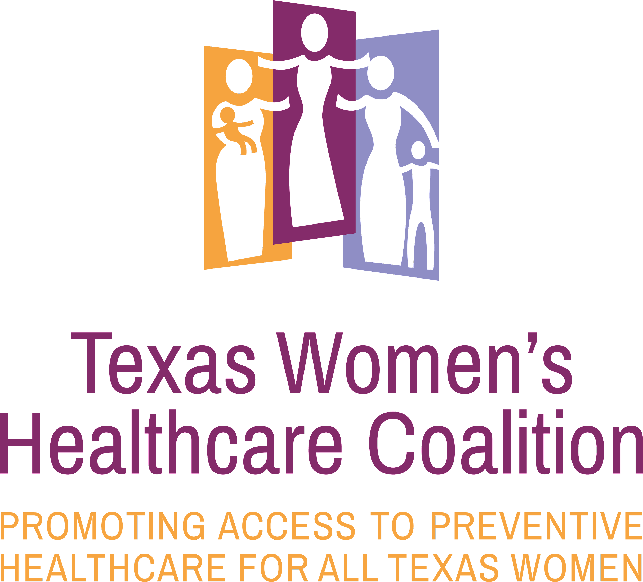

Healthy Futures of Texas (HFTX)
Job Description: Policy and Data Intern
Texas Women’s Healthcare Coalition Project

Healthy Futures of Texas is a nonprofit organization dedicated to reducing teen and unplanned pregnancy in Bexar County and surrounding areas. We believe that all young people deserve to reach their full potential— and become parents at a time that is right for them and their family.

JOB TITLE: Policy and Data Intern
REPORTS TO: Policy and Advocacy Associate

JOB SUMMARY: This part-time, paid intern position is responsible for supporting the work of the Texas Women’s Healthcare Coalition, including data analysis, research, and policy analysis.

ESSENTIAL JOB FUNCTIONS:
- Data analysis
  - Analyze datasheets in Excel and produce graphs to communicate trends
  - Communications analytics - analyze monthly reports, use graphs and other tools to depict trends
- Data entry
- Synthesize complex policy and meeting discussions into understandable documents like meeting minutes for dissemination
- Create maps using data (e.g. of coalition member organizations across the state, populations)
- Map population and health data by legislative districts in Texas
- Conduct research and literature reviews in relevant areas such as, but not limited to:
  - Disparities in reproductive health and access to preventive healthcare services in Texas and the US
  - Contraceptive methods utilization and trends
- Media contact research
- Other duties as assigned

EDUCATION AND EXPERIENCE QUALIFICATIONS:
- Bachelor's degree
- Experience collecting data for research and study purposes
- Experience managing and analyzing quantitative/qualitative data sets
- Demonstrated passion for social justice, particularly reproductive justice
- Strong organizational skills, including the ability to work independently and manage own projects in a fast‐moving environment
- Excellent verbal and written communication skills
- Personal transportation and cell phone

PREFERRED QUALIFICATIONS:
- Current graduate student or recent graduate of a master’s program in public health, policy, public administration, public affairs or related field
- Experience with the legislative process at the state level, particularly in Texas
- Knowledge of and comfort with reproductive and sexual health issues
- Bilingual (English and Spanish)
- Proficiency with social media, such as Facebook, Twitter, Emma, and WordPress

WORKING CONDITIONS & TRAVEL REQUIREMENTS:
- Virtual, In office, and possible occasional travel to San Antonio office

APPLICATION PROCEDURE: Please email a cover letter describing interest and qualifications, a resume. and a list of 3 professional references to: eramirez@hf-tx.org

APPLICATION CLOSE DATE: Open until filled. Ideally for a mid-end January start date.

Healthy Futures of Texas is an equal-opportunity employer; women, people of color, members of LGBTQ communities, and people with disabilities are encouraged to apply. Applicants should be aware that a criminal background check and drug screen will be required prior to hiring.

